CS691 - Computer Science, Spring 2018
Project Initiation Document
U-Drive

Project: U-Drive
Project Manager: Mohd Shaarif Khan

Table of Contents
Document Purpose 4
Background to the Proposed Work 4
Vision 4
Project Objectives 4
Project Scope 4
Business Case 5
Assumptions 5
Constraints 5
Risk Management Strategy 5
Deliverables 6
Stakeholders 6
Project Team 6
Project Plan 7
Project Controls 7
Communication Plan 7

Document Details
Version | Modifications | Author | Date
1.0 | Initial PID Document | Mohd Shaarif Khan | 02/05/2018

Approvals
This document requires the following approvals:
Name | Role | Signature | Date | Version
Prof. Yuri | Approver |  | 02/05/2018 | 1.0

Distribution
This document has been distributed to:
Name | Role | Date of Issue | Version
Mohd Shaarif Khan | Project Manager
Rohan Kulkarni | Lead Developer
Nahush Pawar | Product Owner
Vikalp Shastri | Lead Business Analyst
Divya Kodi | DBA
Rahul Vasaikar | Lead QA Analyst
Charitha Suresh | Tester

Document Purpose

This document has been created to record the basic information needed to manage the project. The document will describe the scope, objectives, tasks, roles and responsibilities, costs and deliverables related to “U-Drive” website.
The PID dictates the following critical aspects:
- Details of the approach to be adopted for the implementation of the “U-Drive” Project.
- Details of the roles and responsibilities.
- Description of functions and activities.
- Explanation of the processes.
- Details of the communication plan between team members and with the stakeholders.
- Quality records, risks, project controls and exceptions.

The sections of this document are dynamic and could potentially change over the lifetime of the project. The changes will be recorded in the PID document. The PID will be referred each time when a major decision is taken about the project. Also, the PID document will be used at the end of the project to measure whether the project was managed successfully or not and weather all deliverables were produced in timely manner or not.

Background to the Proposed Work

Through “U-Drive” website we present a comprehensive solution for Car booking. This powerful website is specifically designed for users to book cars online. This intuitive visual interface makes day-to-day aspects of booking, refunding of on-going car rentals fast and easy for both the user and administrators. U-Drive is a car sharing marketplace where travelers can rent any car they want, wherever they want it, from a vibrant community of local car owners. Travelers choose from a totally unique selection of nearby cars, while car owners earn extra money and help fuel their adventures.
A pioneer of the sharing economy and travel industry, U-Drive is a safe, supportive community where the car you rent is part of a story, not a fleet. Whether it’s an F-150 truck to help out on moving day, a Tesla for a luxurious weekend away, or a classic VW bus for a picture-perfect road trip, travelers rent the car and own the adventure.

Vision

Internet based car rental system, which can be accessed by any internet based device (Laptop, mobile device, etc). In this the user can rent a car for a particular period of time and will be charged according to miles traveled.

Project Objectives

- Create a user friendly interface.
- To create online car rental reservation website that show cars available in nearby location.
- There are 2 type of users, who wants to rent a car and who wants to give car for rental purpose on our portal.
- Register user with login id and password
- To provide details like type and price of car, seating capacity, rate per miles.
- To provide booking cancellation.
- User will be able to write a review of car they rented.
- User will have an option to buy travel insurance.
- Payment gateway.

Project Scope
Our scope is to create a Car Rental website which deals with following scope categories.
Technical:
- To apply the best UX/UI practices.
- To decide what DB to use.
- To decide what SDLC methodology to implement.
- To discuss roles and responsibilities in a team.
- To install the required software.
- To ensure that the team members have necessary skills.
- To set up development, staging and production environments.
Functional:
- User will be able to view the cars which are available for rent.
- The third party provider will be able to see if the car is booked along with the driver information and also has the right to approve or disapprove the booking.
- User will be able to book the car and can check the approval status.
- User will be provided with booking confirmation on Email or contact number after successful booking and payment procedure.
- Car ratings will be available for user.

Business Case

This project is aimed to provide customers the facility of car rental service online from anywhere at any time. We provide all the cars available on our rental platform similar to ‘zoomcar’. This system provides customers the online service to gather information about available car on our portal. The customer can easily get information about Cars like, type of car and review the cars too. The website includes a refund facility which makes it more friendly, incase customer wants to cancel booking. The website has a backend interface for convenience of Administrator to manage the website (like creating, updating new car or facility and current available records).

Type of business model | Online Car rental system
Target audience of users | User who want to rent a car and Third party providers who want to provide their cars for rent.
Value proposition | Users get access to the list of cars provided in nearby location with the description, reviews and allow them to reserve cars online according to their requirement.
How the system is used | User can reserve a car online and also schedule car reservation a week ahead. User can write review to the rental service provided. They can also filter and find cars according to car type, miles included.
Revenue generation | U-Drive will charge the User who is renting the car through the portal. Also, the application will share the revenue through advertisement.
Partners/Suppliers  (Stakeholders) | - U-drive
Expected Benefits | - To provide anywhere anytime booking services  - To promote the expedited renting service online  - To provide booking service according to the nearby user location.  - To increase profit  - To minimize staff

Assumptions

Assumption | Validated by | Status | Comments
Project Budget (approx. 100$) | All Members | Incomplete | N/A
Participation Time (10hr/week) | All Members | Completed | All members have decided to at least provide 6 hours per week to this project
Project Resources | QA Analyst | In Process | Analyst will check(Update) all the devices and resources every two week
Meeting (Twice every week) | Manager | Completed | Manager will schedule Two meetings every week
Updating Skill | Business Analyst | In Process | Business Analyst will provide specific ‘Required Skills for this Week’ in first meetings of every week
Team Work | Manager | In Process | Manager will keep details of all Modules and will assign ‘Single or Team’ work on specific modules.
Keep Same Technology for development | Business Analyst | In Process | Business Analyst will keep the track of latest technologies for the development
Web-Space will be available | Manager | Incomplete | We will be using the web space provided for every student by the pace university
Requirements will not change | Owner | In Process | Owner is responsible for the requirements of the project and will decide main features before the development
Team Member will stay same | All members | Complete | All members have decided to take Project II in next semester

Risk Management Strategy

Risk management planning is the process of developing options and actions to enhance opportunities and reduce threats to project objectives. Risk management implementation is the process of executing risk mitigation actions. Risk mitigation progress monitoring includes tracking identified risks, identifying new risks, and evaluating risk process effectiveness throughout the project.

Identify Risks Probabilities and consequences
of risk events are assessed
Assess probability & consequences
1. Risk Identification
2. Risk Impact Assessment
Risk Tracking
4. Risk Mitigation planning, Implementation and progress Monitoring

Reassess existing risk events Assess Risk Criticality
Watch listed Risks

3. Risk Prioritization Analysis

Risk Mitigation
Risk events assessed as Medium or High Criticality
Might go into risk mitigation planning and implementation
Low Critical risks might be tracked/monitored on a watch list.

Risk Management Plan

Risk mitigation planning, implementation, and progress monitoring are depicted in above Figure.
As part of an iterative process, the risk tracking is used to record the results of risk prioritization analysis (step 3) that provides input to both risk mitigation (step 4) and risk impact assessment (step 2).
The risk mitigation step involves development of mitigation plans designed to manage, eliminate, or reduce risk to an acceptable level. Once a plan is implemented, it is continually monitored to assess its efficacy with the intent of revising the course-of-action if needed.

Risk | Probability | Impact | Mitigation Method
Vague ambiguous requirements | High | High | Through many sprints the requirements will be revised many times  to ensure that clarity is achieved among every team member.
Obtaining the right skills | Medium | Medium | Prior to the project start date, skill matrix must be created to ensure that  all team members have necessary skills and experience.  Team members that lack key sills must be assigned to classes to obtain these skills.
Project will take more time for the team  to complete than the allocated time. | Medium | Medium | Allocating the time for each module in the application development and testing.  Setting the delivery date to developing team to drop the build to testing team.  By Allocating the buffer time for each module both for development and testing and  calculating the project completion time including these buffer period,  we can avoid the delays in the project completion.
New technologies | Low | Low | the more experienced team member will try and  educate/guide other team members with new technologies.

Ambiguous requirements are the significant risk factors and these lead to confusion, wasted effort and rework. Ambiguity means that a single reader can interpret the requirement in more than one way or that multiple readers come to different interpretations. In either case, ambiguous requirements lead to confusion, wasted effort and rework.
Common types of requirements ambiguities are listed below.
- Negative requirements
Negative, or inverse, requirements state what the system will not do. Here's an example from an actual project: "All users with three or more accounts should not be migrated." In this case, rephrase negative requirements into a positive sense: "The system shall migrate only users having fewer than three accounts." When changing a negative requirement into a positive one, we often need to insert the word "only" to clarify the conditions that permit the system action to take place. Double and triple negatives are especially confusing; we will avoid them in all situations.

- Boundary conditions
Boundaries between numerical ranges or date ranges are a common source of missing requirements. Similarly, if two requirements are written so that the endpoint of a range appears in both requirements, the expected behaviour is ambiguous. Use of words "inclusive" or "exclusive" to make it clear whether the endpoints of the range are included or not.

- Synonyms and near synonyms
Using specialized terms consistently throughout the project documentation. If project involves several terms that have similar but not identical meanings, we put those into a glossary so everyone knows where to go for the exact definitions.

- Pronouns
Pronouns offer another opportunity for confusion if the antecedent is for each pronoun is not clear. If we say "this" or "that," there should be no confusion in the reader's mind as to what we are referring to.

Deliverables
Date | Item | Owner
JAN 29 | Project proposal | Project Manger
FEB 5 | PID Document | Project Manger
FEB 13 | Project Plan, RACI | DBA
FEB 20 | Requirement Types | Product owner
FEB 27 | Analysis Diagram | Lead Developer
MAR 6 | User Requirement | Lead BA
MAR 20 | RCT | Lead BA
MAR 27 | Functional Requirement | Lead Developer
APR 3 | DB model, ER Diagrams | DBA
APR 10 | Architecture Diagrams | Lead QA
APR 17 | UML Design Diagrams | Product Owner
MAY 1 | Test Documentation | Lead QA
MAY 8 | FINAL PRESENTATION | Project Team

Stakeholders

Stakeholders | Interests
Project Manager | The Project Manager develops the Project Plan with the team  and manages the team’s performance of project tasks and to  secure acceptance and approval of deliverables from the  Project Sponsor and Stakeholders.
Project Team | Team will be for executing tasks and producing deliverables as outlined in  the Project Plan and directed by the Project Manager,  at whatever level of effort or participation has been defined for them.
Distributors | Distributors comprise the business units that identified the  need for the product or service the project will develop.
End Users | The persons or organization using the product of the project.
Credit Card Merchant | Organization to except and refund payment.

Project Team

The project team includes the following roles:
- Project Manager – Mohd Shaarif Khan
- Product Owner – Nahush Pawar
- Lead Developer – Rohan Kulkarni
- Business Analyst – Vikalp Shastri
- QA Lead – Rahul Vasaikar
- Tester – Charitha Suresh
- DBA – Divya Kodi

Roles and Responsibilities of the team roles are defined in the RACI Table below:

 |  | Project Roles
Process Area | Project Tasks | Project Manager | Product Owner | Dev Lead | Business Analyst | Test Manager | DBA | Tester
Project Management | Develop a project plan | A,R | C | C | C | C | C | C
Project Management | Provide cost estimate | A,R | C | C | C | C | C | C
Project Management | Hire resources | A,R | C | C | C | C | C | C
Project Management | Establish a project portal on SharePoint | A,R | R | I | I | I | I | I
Project Management | Maintain a project risk and issue log | A,R | R | C | C | C | C | C
Project Management | Provide project status reports | A,R | R | I | I | I | I | I
Requirements | Perform requirements analysts | A | R | C | R | I | I | I
Requirements | Gather business requirements | R | I | C | R | I | I | I
Requirements | Produce functional requirements | A | I | C | R | C | I | I
Design | Produce high-level design specs | A | I | R | C | I | R | I
Design | Produce data model | A | I | C | C | I | R | I
Design | Produce detailed design specs | A | I | R | C | I | R | I
Coding | Establish a code repository | A | I | R | I | I | I | I
Coding | Develop component code | A | I | R | I | I | I | I
Testing | Develop a test plan | A | I | C | C | R | C | R
Testing | Establish a test repository | A | I | C | I | R | I | R
Testing | Develop test specifications | A | I | C | I | R | I | R
Testing | Execute testing, report defects | A | I | I | I | R | I | R
Testing | Conduct defect review calls | A | I | C | R | R | C | R
Testing | Produce, deliver defect metrics | A | I | C | R | R | I | R
Testing | Support test environments | A | I | R | C | C | R | C
Deployment | Produce a deployment plan | A | I | R | I | I | R | I
Deployment | Produce deployment procedures | A | I | R | I | I | R | C
Deployment | Deploy software into production | A | I | R | C | C | R | C

Project Plan
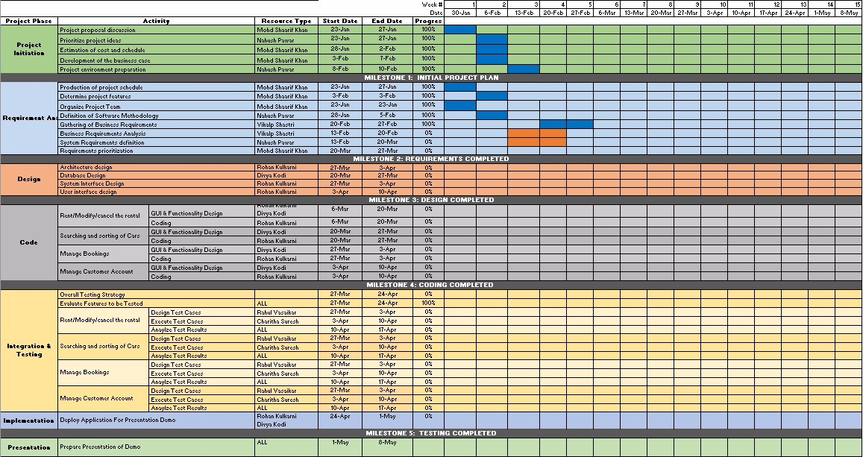

Project Controls

Official language of the project will be English. Official meetings will be held in English. All project documentation and presentations will also be written in English.
Project manager will be organizing two weekly meetings. All the team members are allotted their work that has to be completed before each week
In case any member cannot make for the meeting, manager should reschedule a meeting or held it online through Skype or Google Hangouts. The most of the asynchronous communication will be done on Skype for Business.
Important points and topics will be discussed in the meetings. Final decisions will be made by the end of the meetings taking everyone’s opinion in the consideration.
Weekly meeting minutes will be maintained by the project manager which will also include the progress of the project phases. Manager will also keep a track of the deadlines and ensure that everyone plays their role accurately.
Whatsapp and Google drive will be used to update all the team members with the important information by the manager and for sharing all the files.

Communication Plan
.
Stakeholder | Frequency | Type | Purpose
Project Manager | Daily | Email, Skype for Business, personal meetings, phone | To discuss working progress, estimates, requirements prioritization, role and responsibilities within the team. To discuss any issues related to communication between team members or issues related to team members.
Project Team | Daily | Email, Skype for Business, personal meetings | To discuss working progress, new requirements, mission or incorrect requirements, defects and their solutions and potential issues.
End Users | Potentially during the testing phase and after release. | Email, online testing sessions | To obtain feedback.
Quality Management Team | Daily | Email, Skype for Business | To ensure that all key processes are implemented correctly.

